# Activity 01 Part 3 – Binary to BCD Conversion

Richard Groves

09/05/2023

Class: ECE4/530 - Digital Hardware Design

# 1. Introduction

## 1.1 Objective

## The objective of this activity was to successfully design, simulate, and implement a Binary to BCD (Binary-Coded Decimal) conversion system. This involved: creating a C-module based on the provided truth table, simulating it to ensure correct functionality, and integrating it with a 4-bit 2x4 multiplexer to facilitate the selection and display of individual BCD digits on a set of LEDs.

# 2. Design

## 1.1 Design Approach

### 1.1.1 Binary to BCD Converter

The conversion of binary to BCD was implemented by using C-modules from a provided block diagram and truth table (shown below). A 2x4 multiplexer was used to display the 4-bit binary representation of each decimal of the BCD (ones, tens, hundreds).

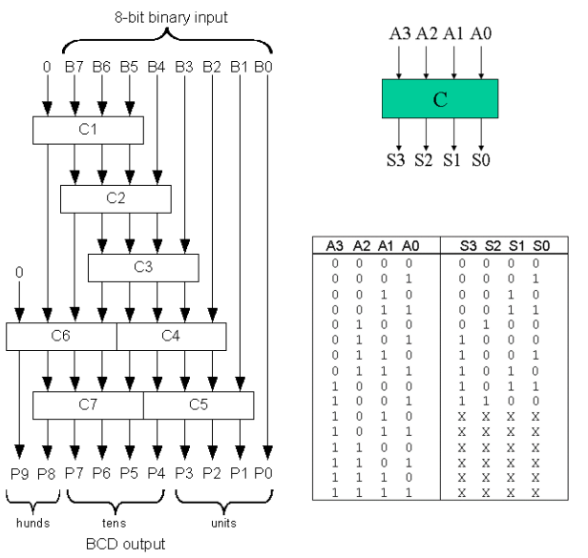 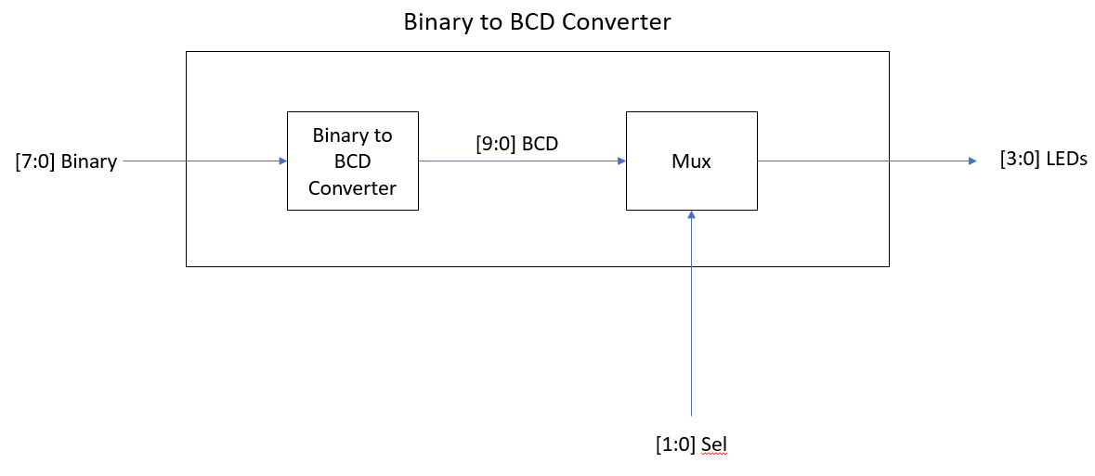

1.2 Design Details

### 1.2.1 Module List

The individual module files are included with this report.

|  |  |  |
| --- | --- | --- |
| Module Name | Module File Name | Module Description |
| C | C.v | This module takes a 4-bit binary input as the address and returns a corresponding 4-bit binary output for the binary to BCD conversion process. |
| Mux_2x4 | Mux_2x4.v | This module is a 2x4 multiplexer. It is designed to select one output from four 4-bit input lines (a, b, c, and d) based on a 2-bit selector input (sel). |
| Binary_to_BCD | Binary_to_BCD.v | This module is designed to convert 8-bit binary inputs to 10-bit Binary-Coded Decimal (BCD) outputs. This module utilizes multiple instances of the "C" module to process a segment of the binary input, and the outputs are then concatenated to form the final BCD output. |
| Binary_to_BCD_Board | Binary_to_BCD_Board.v | This module functions as a board-level module that integrates the functionalities of binary to BCD conversion and multiplexing. It takes an 8-bit binary input and a 2-bit selector input to produce a 4-bit output that is intended to drive LEDs. The 4-bit output is a binary representation each decimal (ones, tens, hundreds). |

### 1.2.2 Schematics

#### 1.2.2.1 Binary to BCD Conversion Schematics

In the schematic for this project, Binary_to_BCD module takes an 8-bit binary input (bin) and converts it to a 10-bit Binary-Coded Decimal (BCD) output. This module uses several instances of module C to facilitate the conversion process, with each instance of C responsible for processing a specific segment of the binary input and generating a portion of the BCD output. The Mux_2x4 module is used for the selection of specific segments of the BCD output based on the 2-bit selector input (sel).

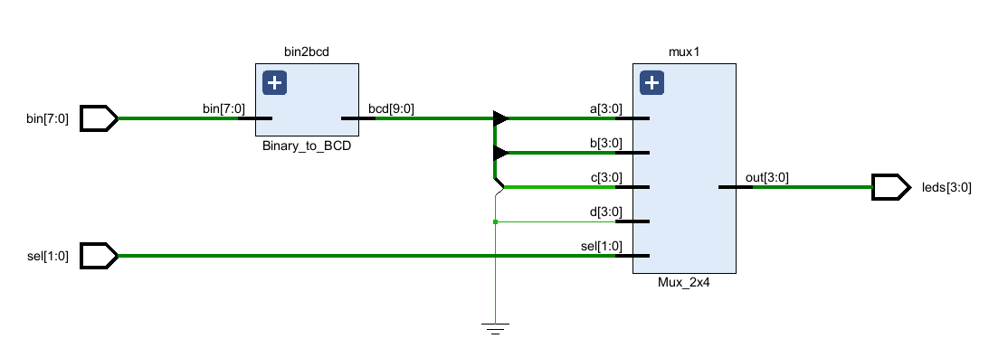 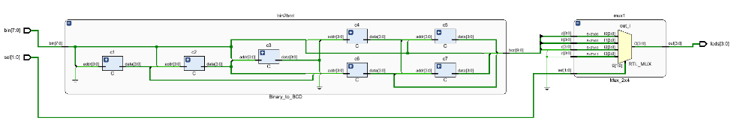

## 1.3 Simulation

### 1.3.1 Testbench Module List

The individual module files are included with this report.

|  |  |  |
| --- | --- | --- |
| Module Name | Module File Name | Module Description |
| tb_C | tb_C.v | This testbench module is designed to evaluate the correctness of the "C" module, a component of converting binary to BCD. It loops through all possible 4-bit addresses (ranging from 0 to 15). |
| tb_Binary_to_BCD | tb_Binary_to_BCD.v | This testbench module is designed to validate the functionality of the "Binary_to_BCD" module. Within this testbench, a loop iterates through all possible 8-bit binary numbers (from 0 to 255), assigning each as an input to the Binary_to_BCD module and observing the BCD output. |

### 1.3.2 Waveforms

#### 1.3.2.1 tb_C Waveform

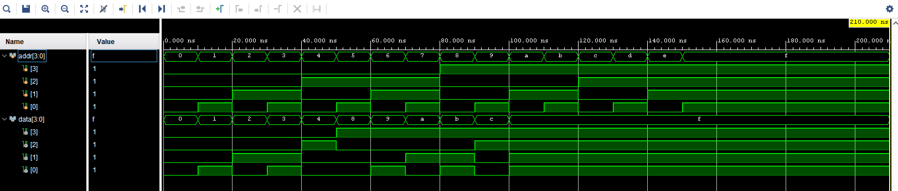

#### 1.3.2.2 tb_Binary_to_BCD Waveform

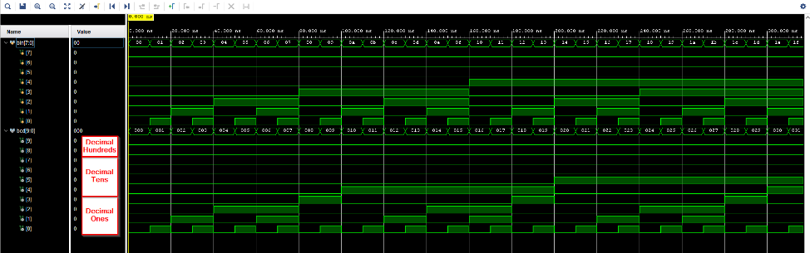 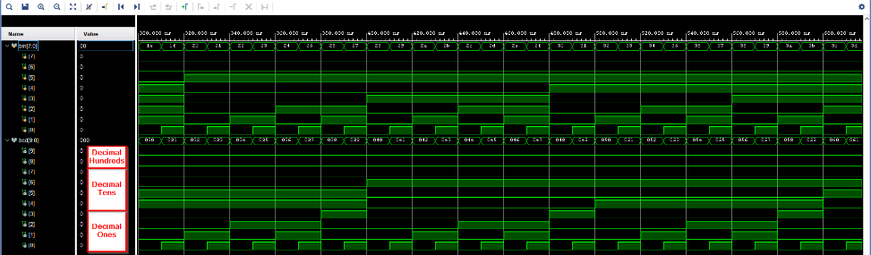 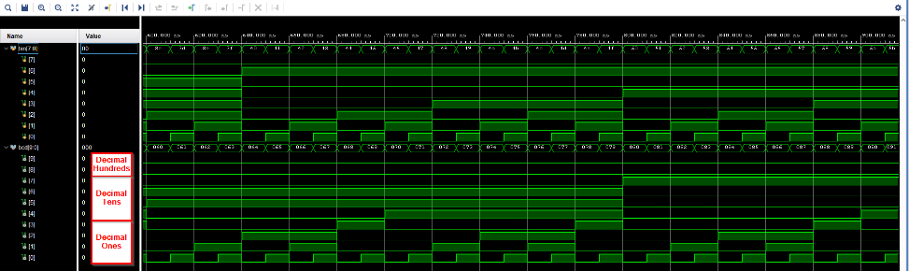 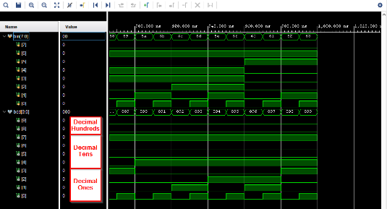

## 1.4 Synthesis

### 1.4.1 Slices/LUTs

|  |  |
| --- | --- |
| Slices | LUTs |
| SLICE_X43Y56 | leds_OBUF[3]_isnt_i_1 |
|  | leds_OBUF[3]_isnt_i_6 |
|  | leds_OBUF[3]_isnt_i_5 |
|  | leds_OBUF[3]_isnt_i_3 |
| SLICE_X42Y56 | leds_OBUF[2]_isnt_i_1 |
|  | leds_OBUF[3]_isnt_i_2 |
|  | leds_OBUF[2]_isnt_i_3 |
|  | leds_OBUF[2]_isnt_i_2 |
| SLICE_X42Y55 | leds_OBUF[0]_isnt_i_1 |
|  | leds_OBUF[3]_isnt_i_4 |
|  | leds_OBUF[1]_isnt_i_3 |
|  | leds_OBUF[0]_isnt_i_2 |
| SLICE_X42Y54 | leds_OBUF[1]_isnt_i_2 |
|  | leds_OBUF[1]_isnt_i_1 |
|  | leds_OBUF[0]_isnt_i_3 |
|  | leds_OBUF[1]_isnt_i_5 |

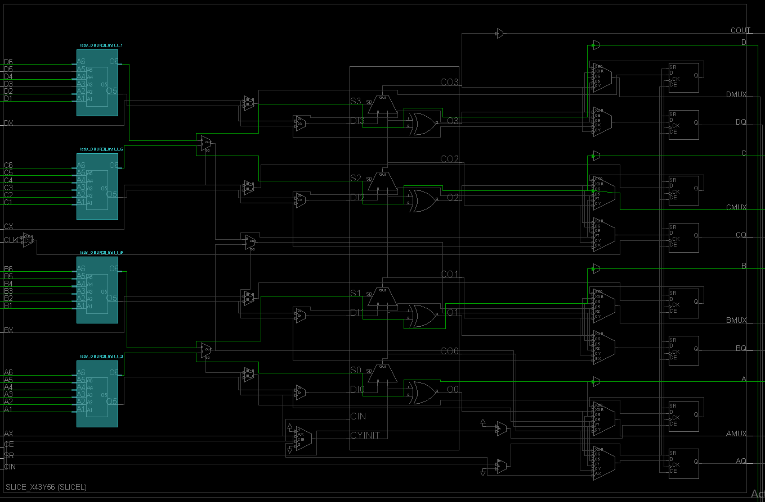

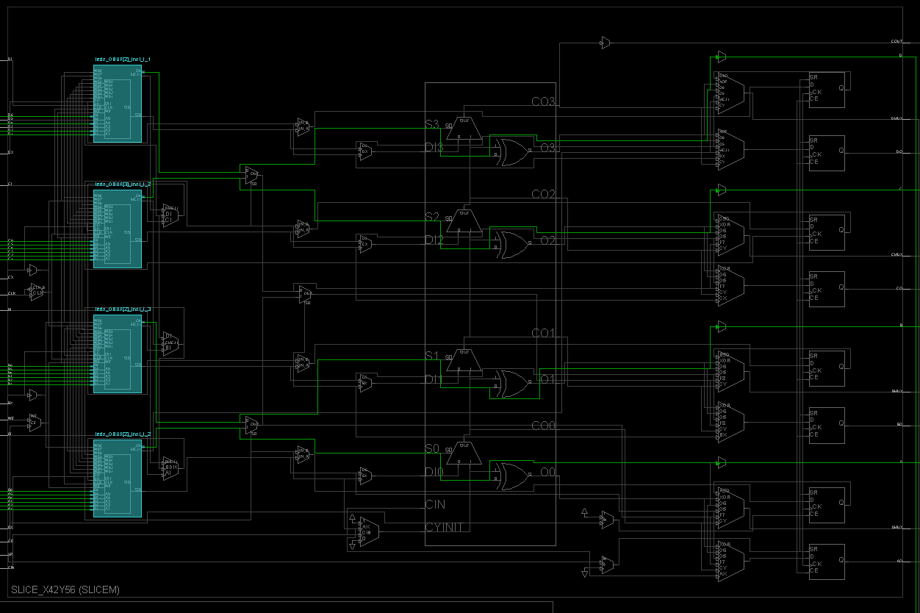

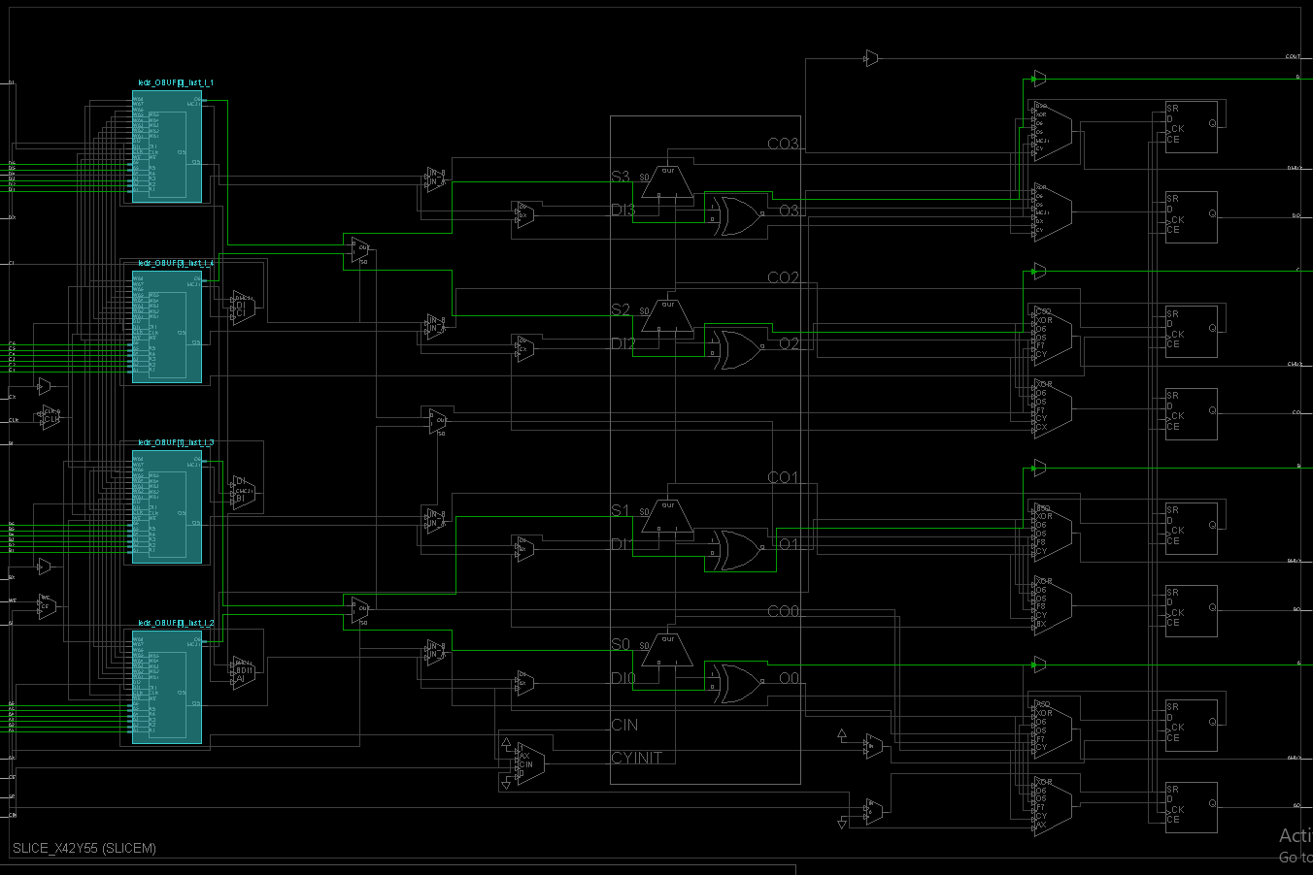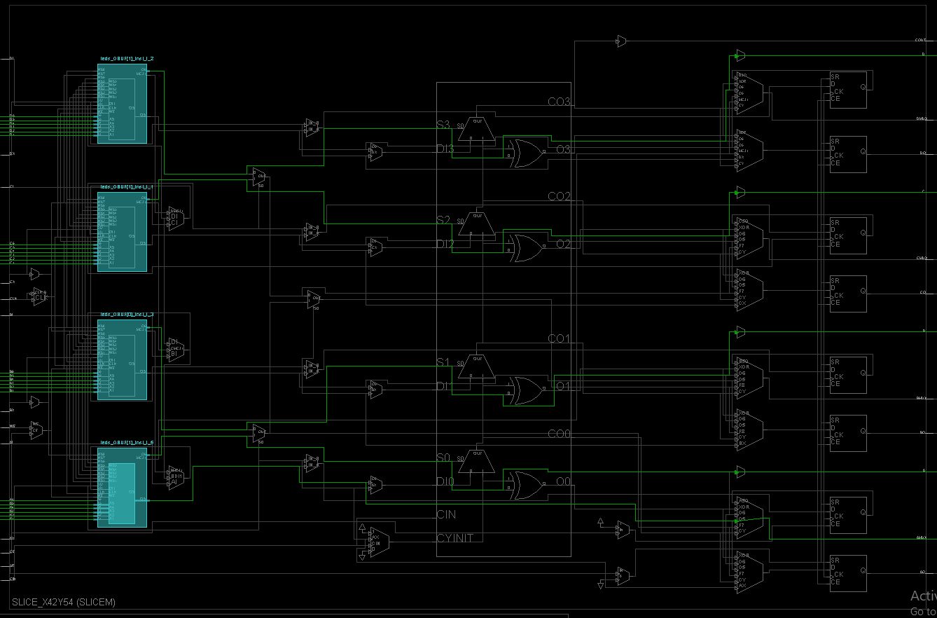

## 1.5 Implementation and Testing

### 1.4.1 Implementation Files

These implementation files are included with this report.

|  |  |
| --- | --- |
| File Name | File Description |
| Binary_to_BCD_Board.bit | This is the bitstream file for the binary to BCD conversion project. |

### 1.4.2 Testing

#### 1.4.2.1 Conversion of Decimal 128

The images below show a test of decimal 128 on the ZYBO-Z7 board.

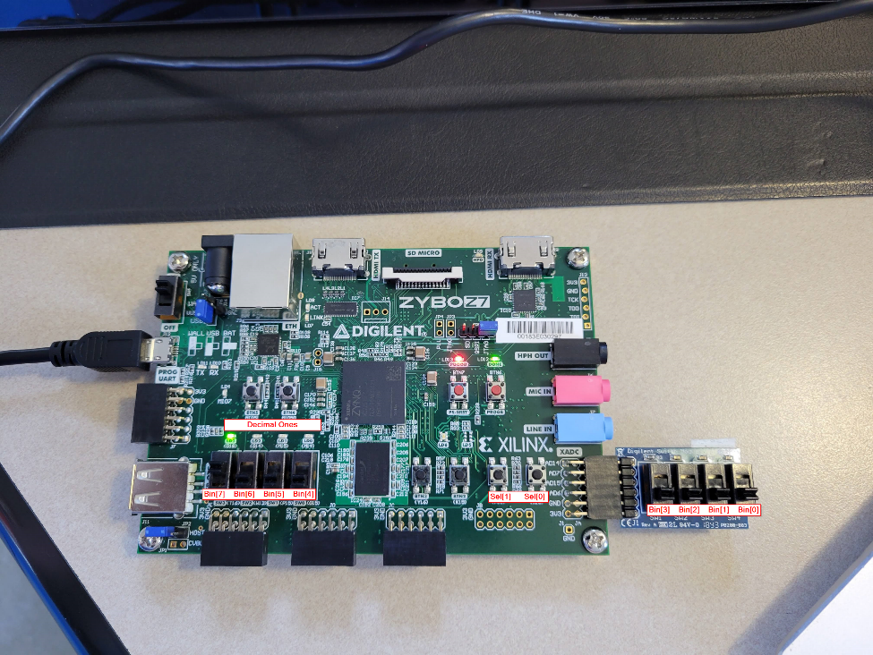

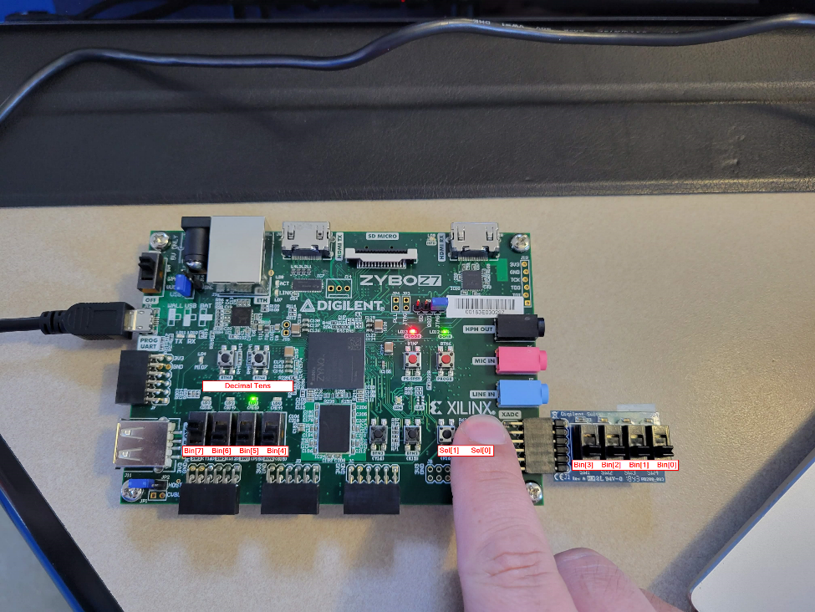

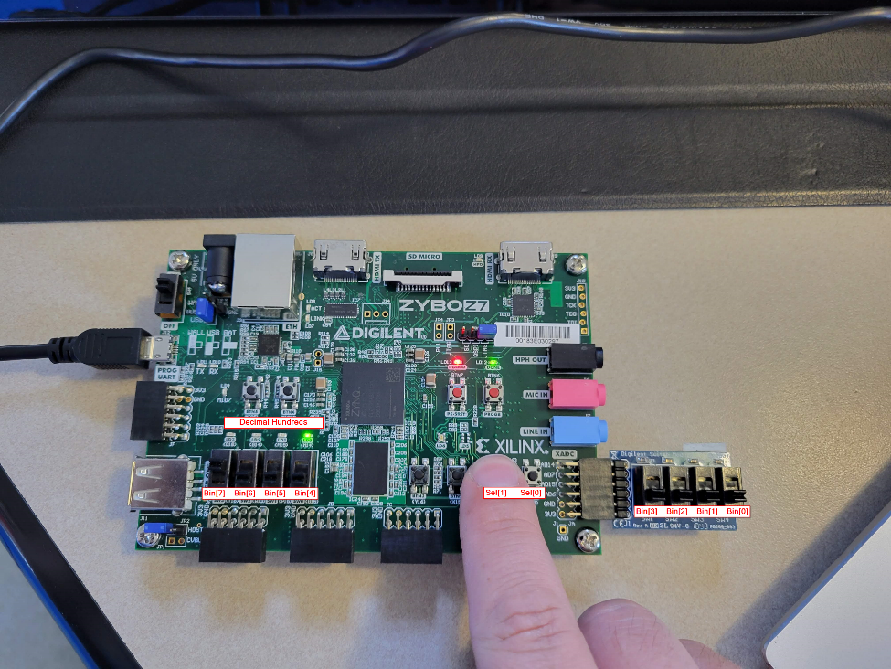

#### 1.4.2.1 Conversion of Decimal 152

The images below show a test of decimal 152 on the ZYBO-Z7 board.

